Carbon Cycling:
Environmental Processes that Change Our World

Middle/High School

TEACHER GUIDE

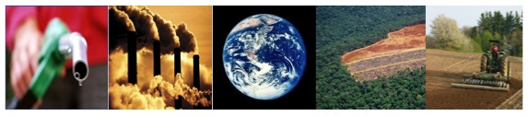

Lindsey Mohan, Jonathon Schramm, Li Zhan, & Andy Anderson
Environmental Literacy Project
Michigan State University
March 2009
Outline of Activities

Overview and Background for Teachers: 3
MAterials List 4
TOOLS 5
Carbon Cycle Diagram 5
Scale 6
Powers of Ten Representation 1 6
Matter and Energy Process Tool 7
Activity 1: Initial Ideas about Carbon Cycling 8
Activity 2: Where Is Carbon Dioxide Going? 13
Activity 3: How are Plants Different? 16
Activity 4: Plants and the Carbon Cycle 22
Activity 5: Organisms Give Off Carbon Dioxide 28
Activity 6: What Happens to dead plants and animals? 34
Activity 7: Soil and the Carbon Cycle 38
Activity 8: Putting It All Together 41

Important things:
- Decided the storyline we want to start with for Activities 1 and 2
- Should students be given more than images of plants to complete Activity 4?
- Write Activity 5 on respiration in organisms with the energy pyramid as a potential activity
- Add Decomposer lab to Activity 6
- Write Final Activity 8 that puts all the pieces together (except combustion)

Other things that need to be finished:

- Write overview and background
- Write a materials list
- Choose embedded assessments
- Select or make a carbon cycle diagram we want to use
- Make Powers of Ten powerpoints to go with Activity 2 and 6 (one on plants and the other on decomposers)- add these to activity procedures

Overview and Background for Teachers:

MAterials List

TOOLS

Carbon Cycle Diagram
With Answers
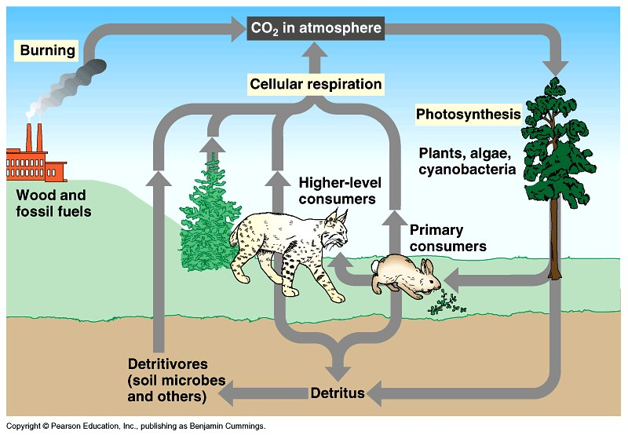

Blank, Simplified Diagram
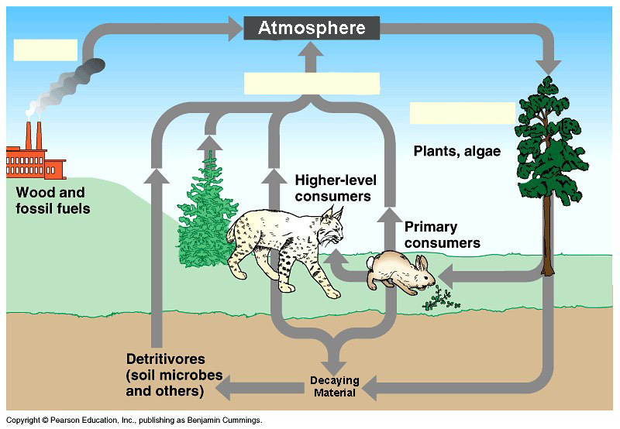

Scale

Powers of Ten Representation 1
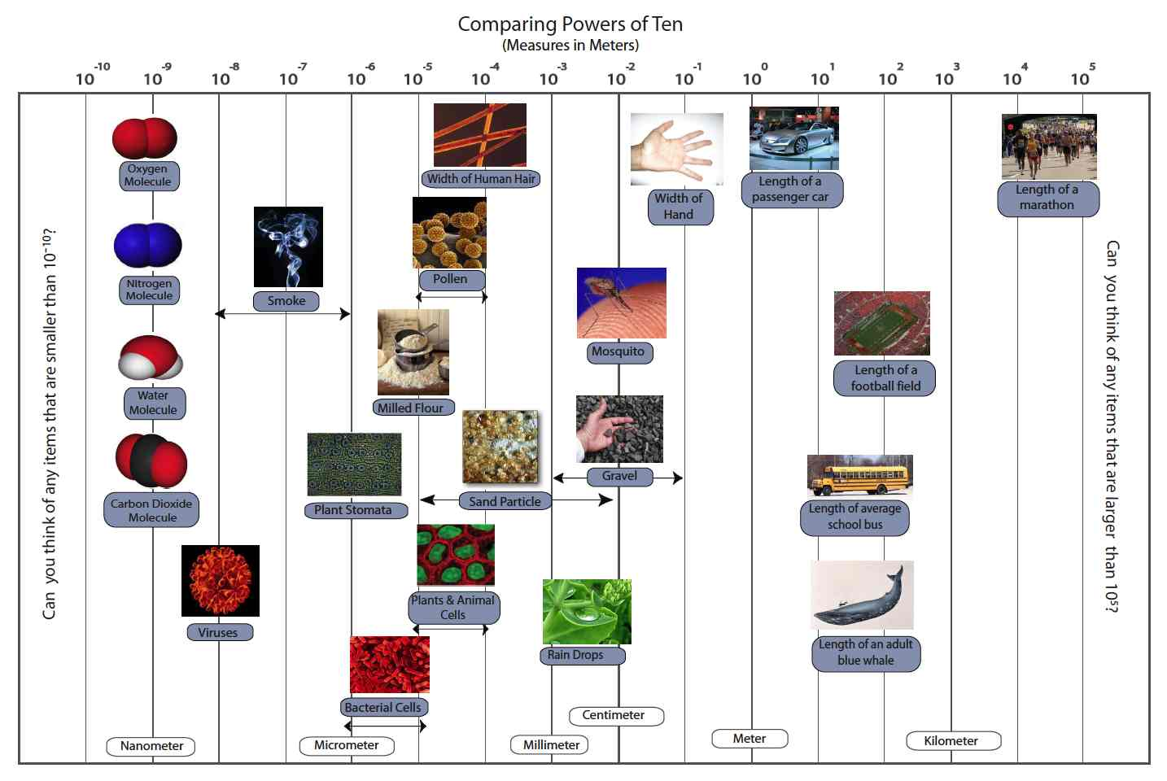

Matter and Energy

Matter and Energy Process Tool
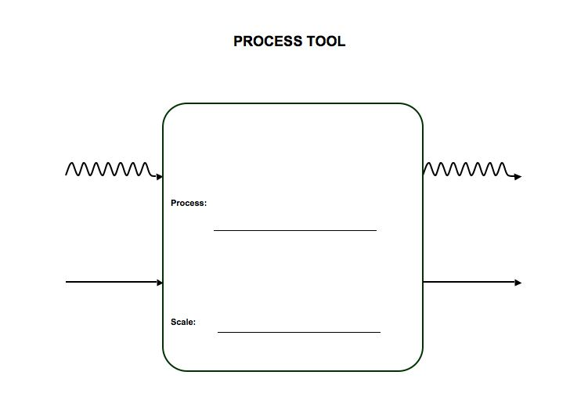
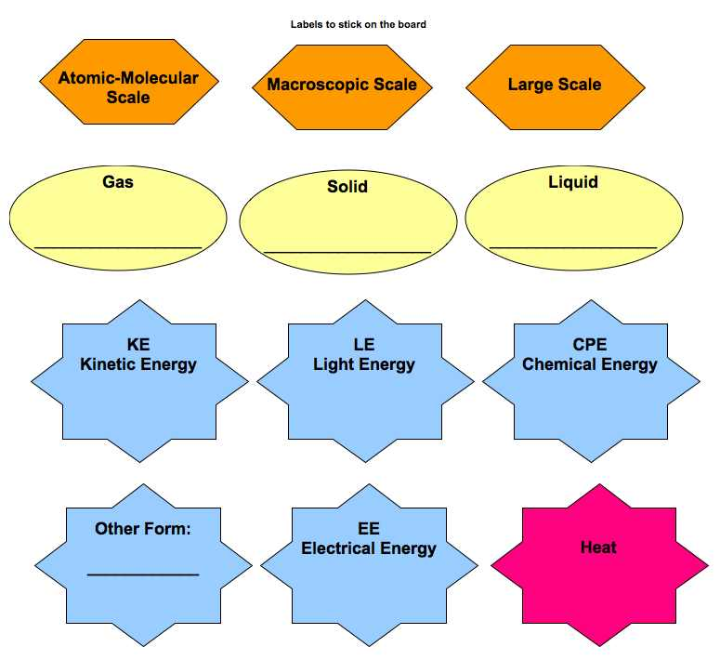
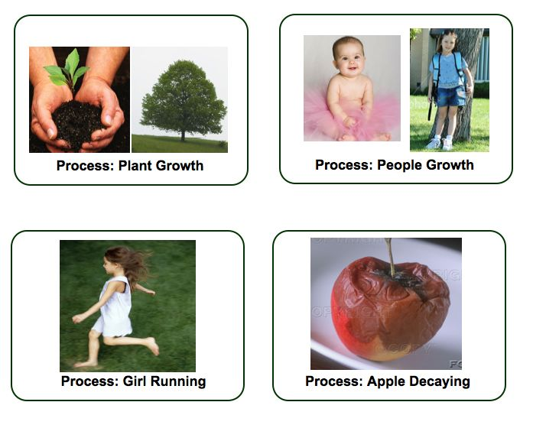

Activity 1: Initial Ideas about Carbon Cycling

Overview
Carbon Dioxide & Processes ~25 minutes
Forms of Carbon ~25 minutes

TOTAL TIME: 50 minutes

Purpose

This series of lessons teaches students about carbon cycling processes in terrestrial ecosystems. While this unit teaches about metabolic processes that occur in individual organisms, such as photosynthesis and cellular respiration, the processes are situated in the context of large-scale systems. In this first activity students are asked to think about processes that change the amount of carbon dioxide in the air. They discuss how different types of organisms change the air around them. Then students learn about two forms that carbon is often found in: organic carbon and carbon dioxide. The lesson introduces students to the idea that carbon cycling is mainly about finding out where carbon is located, and in what form.

Materials
Student copies of worksheets Initial Ideas about Carbon Cycling
Overhead or paper to record students’ questions

Advance Prep
Make copies and overheads if not supplied by MSU

Procedures

Processes that produce and consume carbon dioxide ~25 minutes
Ask students to suggest processes that affect the level of carbon dioxide in the atmosphere. Spend about 10 minutes brainstorming ideas.

Then pass out worksheet Initial Ideas About Carbon Cycling. Ask students to complete part 1 which allows them to write their ideas about how different organisms change the air around them.

Discuss their ideas about where the carbon is coming from and going to.

Important Forms of Carbon ~25 minutes
So another big question we face is: Where will the carbon be? Will it stay in a solid or liquid form (organic carbon), or will it enter our atmosphere as carbon dioxide?

Ask students, “What is carbon?” This question assesses whether they understand that carbon is an “atom” or “element” found in nature. It’s okay if students’ initial ideas about carbon are incorrect, but it’s important to get a sense of whether students see carbon as matter in the forms of atoms.

Tell students to take a minute to complete the table in Part 2. This table asks students to share their initial ideas about the different locations of organic carbon and carbon dioxide.

Ask students to share what they put in this table. As they share make sure to probe what students know about chemical substances (substances found in foods, fuels, body structures, etc). Also make sure to ask whether the carbon is found in a solid, liquid or gas substance.

Allow students several minutes to think about answers to the last 2 questions on their handouts- the main processes that take in or give off carbon dioxide. Students may know that photosynthesis is the main processes that takes in CO2 and makes organic carbon, but they may not be able to identify the primary processes that give off CO2. Students need not rank order the processes, but identifying combustion and cellular respiration/decay would be a good start to the unit.

With any remaining time, allow students to share their own questions and make of list of these questions to go back to later in the unit.

Name:____________________________________________Period/Hour:________

Initial Ideas about Carbon Cycling

In this activity, you will share what you know about the carbon cycle. You will need to think about molecules that contain carbon and the different events and processes that move carbon between organisms and objects and the air around them.

Part 1: How Does Carbon Move or Change?
The questions below are about four processes that take in or give off carbon dioxide.

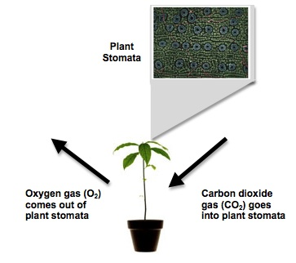
Trees Growing
1. Look at the arrows going into and out of the plant. You may have heard that plants take in carbon dioxide and give off oxygen. What do you think happens to the carbon atom that was once in the carbon dioxide molecule?
________________________________________________________________________________________________________________________________________________________________________________________________________________________________________________________________________________________________________________________

People Breathing
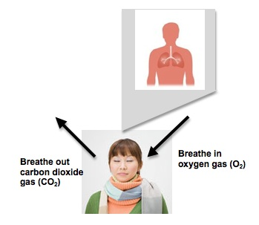
2. Look at the arrows going in and out of the person. You may have heard that people and other animals breathe in oxygen and breathe out carbon dioxide. Where do you think the carbon that is in the carbon dioxide comes from?
_____________________________________________________________________________________________________________________
______________________________________________________________________________
______________________________________________________________________________

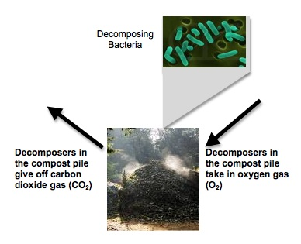
Compost Decaying
3. Look at the arrows going into and out of the decomposers in the compost pile. Decomposers need oxygen to decompose dead plants and animals. They give on carbon dioxide. Where does the carbon in the carbon dioxide come from?
_____________________________________________________________________________________________________________________
______________________________________________________________________________
______________________________________________________________________________

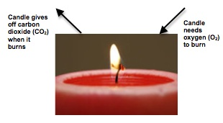
Candle Burning
4. Look at the arrows going into and out of the candle. Candles need oxygen to burn and give off carbon dioxide. Where does the carbon in the carbon dioxide come from?
____________________________________________________________________________________________________________________________________________________________________________________
____________________________________
____________________________________
Part 2: Types of Carbon
There are two important forms of carbon molecules: Organic forms of carbon molecules and carbon dioxide molecules. Organic carbon molecules contain carbon and are found in living and once-living things. Carbon dioxide molecules contain carbon and are found as a gas in the air.

5. Think of places where you might find organic molecules and carbon dioxide molecules. Complete the table below.

Organic Carbon | Carbon dioxide

6. Look at your list of where you would find “Carbon dioxide”. What do you think are the main processes that put carbon dioxide into the air?
____________________________________________________________________________________________________________________________________________________________________________________________________________________________________

7. Look at your list of where you would find “Organic Carbon”. What do you think are the main processes that take change carbon dioxide into organic carbon?
____________________________________________________________________________________________________________________________________________________________________________________________________________________________________

Your Questions
Think about questions you have about carbon cycling. Write down 1-2 questions you would like to learn about as you study more about this topic.

Question 1: _________________________________________________________________
____________________________________________________________________________

Question 2: _________________________________________________________________
____________________________________________________________________________

Activity 2: Where Is Carbon Dioxide Going?

Name: ______________________________________________ Date: _____________________

Where is Carbon Dioxide Going?

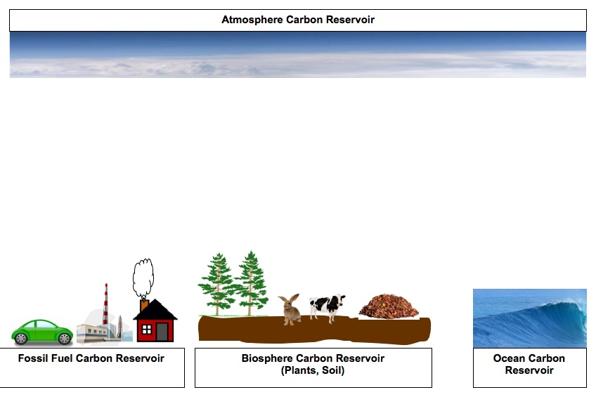
Look at the different reservoirs, or locations, where carbon is found. In this activity you will think about how carbon dioxide moves between these locations. Draw arrows going down showing which locations (including organisms) take in carbon dioxide. Draw arrows going up to show which locations (including organisms) give carbon dioxide off.
Questions

1. If the arrows that go in and out of the biosphere were equal, what do you think would happen if we then decided to cut down trees to make room for a new neighborhood? _______________
____________________________________________________________________________________________________________________________________________________________________________________________________________________________________

2. What would happen to the arrow from the fossil fuel reservoir if we choose to have more cars running on gasoline, and use more fossil fuels to power our homes? ______________________
____________________________________________________________________________________________________________________________________________________________________________________________________________________________________

3. How are the plants in the ocean and plants on land different from other things in how they move carbon dioxide? __________________________________________________________
____________________________________________________________________________________________________________________________________________________________________________________________________________________________________

Activity 3: How are Plants Different?

Overview
Review Photosynthesis ~10 minutes
Elodea Demonstration/Lab ~30 minutes
Process Tool and questions ~20 minutes
Photosynthesis Process Tool ~10 minutes

TOTAL TIME: 40 minutes

Purpose
The purpose of this activity is to introduce students to plants’ critical role in carbon cycling. This activity is not intended to teach photosynthesis, but instead to review what students already know about photosynthesis with a focus on how CO₂ gas contributes to plant mass (i.e., how plants change CO₂ gas into stored organic carbon). Students should already be familiar with photosynthesis, but many students may believe that water, soil, or sunlight contribute to plant mass, and may not know or may forget about the CO₂ as a key material. This lab shows that plants (using elodea as an example) take in carbon dioxide. Importantly, after students complete the lab investigations, they have the opportunity to use the process tool to track matter and energy transformations in plants.

In depth knowledge of gas exchange in plants is critical to understanding how to trace matter in natural systems. Middle and high school students have limited understanding of gas exchange is plants, with many students not aware that both CO₂ and O₂ are taken in and released by plants. The goal of this activity is to make the gases more visible to students. The Watching Plants Breathe lab will demonstrate the gas exchange that occurs in photosynthesis—especially that plants need a source of carbon dioxide for the process of photosynthesis. Comparison can be made on various amounts of time, distance between light source and plant, and amount of CO₂ supplied (baking soda).

Materials
Student copies of Why Are Plants Different?
Process Tool Class Chart and/or overhead
Plant lab (per group)
2-4 sprigs Elodea
2 test tube with cap or glass jar with lid
1 erlenmeyer flask
1 Straw
.04% solution of BTB
60-watt lamp & bulb or grow light
Plant Powerpoint (zooming into a plant cell)

Advance Prep
Make Copies of overheads and worksheets if not supplied by MSU
Have Process Tool (chart or overhead) ready for use.
Gather supplies for lab (consider testing lab in advance)

Procedures

Review Photosynthesis ~10 minutes
Display the diagram from activity 2 and point to the arrows going into aquatic and terrestrial plants. Tell students in the previous lesson they learned about important reservoirs of carbon and key processes that move carbon dioxide into and out of the atmosphere. Today they are going to focus on learning more about why plants are different and their key role in carbon cycling.

In order to better understand what students already know about plants and CO₂, review students’ ideas about photosynthesis. Ask students, “If plants take in CO₂, what do they do with it? How is it used?” Allow students to share any of their ideas about photosynthesis. Some common misconceptions about photosynthesis include:
1) CO₂ is a gas and does not contribute much to plant weight (actually carbon from carbon
dioxide makes up at least 50% or more of plant dry matter),
2) sunlight actually turns into food or matter for plants (violates conservation laws),
3) water is the main source of mass (or weight) for plants,
4) soil contributes to plant weight.

As students share what they know about photosynthesis, be particularly attentive to these common misconceptions.

Plant Lab and/or demo ~30 minutes

This lab activity shows that plants take in carbon dioxide. Use it as a lab investigation for students to conduct, or a demonstration conducted by the teacher.

See instructions for lab on the following pages. Have students conduct the lab and share their observations. Did they find that plants take in CO₂?

This lab activity assumes that students have already learned about photosynthesis, but that they may still be confused about the role of CO₂ is that process.

Photosynthesis Process Tool & questions ~20 minutes
After the lab activity, use the process tool to review photosynthesis with students. Importantly point out that photosynthesis “sequesters” carbon because it transforms CO2 into organic carbon (which has chemical energy).

Also, have students complete the summarizing questions at the end of the activity. Use these questions and student responses to conduct a class discussion.

An important point to make is that plants are made of atoms and molecules that originally came from CO₂ in the air and liquid water. Carbon from carbon dioxide is a really important contributor to plant mass and plants are a very important reservoir because they are the primary organisms that transforms carbon dioxide back into energy-rich organic carbon molecules for all living things on the planet.

Note: Have the Plant powerpoint ready as a reference to scale. Consider zooming into a plant cell to talk about where the changes are happening in the plant.
Is CO₂ an INPUT for photosynthesis?

1. Fill a jar with blue BTB to the top. Pour into an Erlenmeyer flask. Do one more time, so there are two vials worth of BTB in the flask.
Vial
Blue BTB

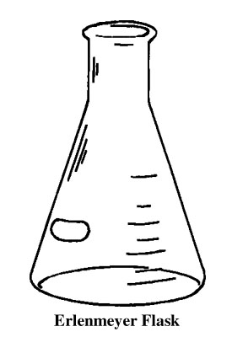

X 2

2. Blow gently into the Erlenmeyer flask with a straw until the BTB JUST turns yellow. Do not blow for too long!

3. Pour the yellow BTB back into the two jars.

4. Put a 2-3 inch long piece of aquatic plant in one jar. Seal both jars tightly!

5. Fill out and tape a label onto your jars.

7. Place jars under the grow lamp on the paper marked for your class. Put the label facing DOWN so it doesn’t block the light.
Fill flask with 2 jars of BLUE BTB
Blow gently into BTB until it just turns yellow. You are adding CO₂
Pour yellow BTB back into jars
Place piece of aquatic plant into one jar
Seal BOTH jars tightly!
Label both jars and put under light.
BTB turns blue
BTB stays yellow
CO₂ has been removed from the water.
CO₂ has NOT been removed from the water
CO₂ is an INPUT for photosynthesis.
CO₂ is NOT an INPUT for photosynthesis.
Is CO₂ an INPUT for photosynthesis?
Name: _________________________________________ Date:__________

How Are Plants Different?

- What types of matter and forms of energy go in and out of plant cells during photosynthesis? Complete the diagram below.

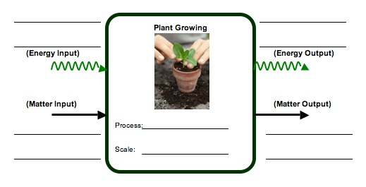

- If someone claimed that a plant’s mass comes mainly from CO₂ in the air, explain why you agree or not agree with that statement. __________________________________________
___________________________________________________________________________________________________________________________________________________________________________________________________________________________
- Using what you know about photosynthesis, explain why plants are important to carbon cycling. ___________________________________________________________________
___________________________________________________________________________________________________________________________________________________________________________________________________________________________

Photosynthesis
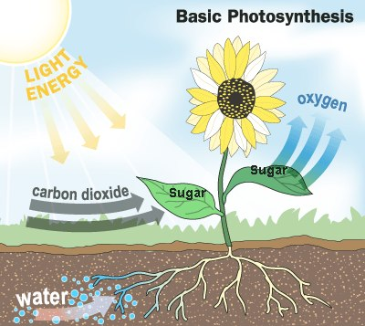
Plants use water from roots, carbon dioxide from air, and sunlight to make sugar.

Plants take sugar they make to all their cells and give off oxygen as a waste

Activity 4: Plants and the Carbon Cycle

General Overview
Introduction: Review of the global carbon cycle, w/ focus on plants. ~ 10 minutes
Small Groups: Exploration of plant types and carbon sequestration. ~ 15 minutes
Whole Class: Implications of plant carbon for global carbon balance. ~ 25 minutes

Estimated Time: 50 minutes

Purpose
This lesson allows students to think more carefully about the important role plants play in global carbon cycling through the processes of photosynthesis and growth. We begin by reviewing the fixation of gaseous CO₂ into plant compounds (initially, glucose), which is one of the primary ways CO₂ is removed from the atmosphere. Then, in small groups, students consider how this general trend plays out in a variety of plant types (annual vs. perennial, woody vs. herbaceous, aquatic vs. terrestrial). Finally, the students come back together as an entire class and report on their findings to the rest of the class, helping to inform a discussion on human land use decisions and carbon sequestration.

Materials
- Powers of 10 class poster
- Optional: Internet access and LCD projector for displaying helpful visuals
- Student handouts of Plants and Global Carbon Cycling
- Gather plant materials ahead of time, either real samples or pictures. You will need one example each of: annual plant (possibly corn or other crop grain), perennial plant (turf grass), herbaceous plant (dandelion), woody plant (tree or shrub), aquatic plant (sample of pond water), terrestrial plant (any potted plant).

Advance Preparation
- Run copies of Plants and Global Carbon Cycling (if not provided by MSU)
- Optional: Set up projector for displaying Internet animations

Procedures
Introductory discussion: Carbon Cycling ~10 minutes
- Begin the discussion by asking students what they think of as the main form of carbon in the atmosphere, and in what context they may have heard about it. If they don’t volunteer it, draw out the idea of carbon dioxide as a gas in the atmosphere. Using the Powers of 10 poster, remind students of the incredibly small size of CO₂ molecules, and move into a brief discussion of how this gas is used by living systems. What vital life process requires CO₂ as a reactant (photosynthesis)? Encourage students to think about the connection between visible plant parts (stems, leaves, etc.) and the atomic-molecular scale CO₂ in the atmosphere. Obviously plants can remove a lot of CO₂ from the atmosphere in the process of growing their tissues. (Note, that later students will learn about plants’ role in returning CO₂ to the atmosphere).
- If time and technology permits, you may wish to show several brief animations found on the “Habitable Planet” website which illustrate the key points of carbon fixation via photosynthesis and mineralization through respiration. They are found at http://www.learner.org/courses/envsci/unit/unit_vis.php?unit=2, and are the first two animations on the list; each is less than a minute long.

Small Group Discussion: Plant Types and Carbon Storage ~15 minutes
- Have the students break up into 6 groups (approx. 4 per group). Distribute the plant samples and/or pictures, one to each group. Have them discuss how much carbon dioxide a plant like theirs is likely to absorb over the course of the growing season, how long it is likely to keep that carbon stored over its life, and what parts of the plant are the largest storage areas for carbon. Make sure they take notes on their discussion and are prepared to share their answers with the rest of the class.

Whole Class Discussion: Human Land Use Decisions ~25 minutes
- Bring the groups back together and have them share the results of their small group discussions using a blank transparency version of Plants and Global Carbon. After the groups have reported, move into a discussion of how human land use decisions can affect global carbon cycling via promoting or discouraging different types of plants. Of particular importance is deforestation, since it replaces long-lived reservoir species with shorter-lived species that will respire most of their CO₂ on a much faster basis. On the other hand, allowing annual cropland to slowly grow back into forests will lead to a high level of carbon storage while that forest is growing. You can also discuss the difference between annual and perennial plants in terms of storage in root tissues. There is a growing movement to increase the proportion of perennial species used as food crops, not least because below-ground carbon storage is much more significant with these species.

Name: ________________________________________ Hour: __________

Plants and Global Carbon Cycling

Different types of plants can store carbon in their bodies in very different places and for very different lengths of time. Working with your group and the plant sample provided, fill out the following table for your sample. Then listen as other groups report on their sample and fill out the rest of the table accordingly.

Plant Type or Species | How much carbon stored each year? (Little, Moderate, Much) | How long will plant store carbon over its life?  (Short-term, Moderate, Long-term) | Where in the plant will most of the carbon be stored?  (Roots, Stem, Leaves, Other)
Annual Grass (Corn) | Moderate | Short-term | Stem
Perennial Grass (Turfgrass) | Little | Moderate | Roots
Herbaceous Perennial (Dandelion) | Little | Moderate | Roots
Woody Perennial (Maple Tree) | Much | Long-term | Stem
Terrestrial (Potted Plant) | Moderate | Moderate | Stem
Aquatic “Plants” (Sample of Pondwater) | Much | Short-term | Other (Single-cell organisms)

1. As people choose how to use different parts of the landscape, which types of plants do you think they should encourage in order to store the most carbon? Which types will be the most help over the longest time? How did you decide?

2. What is the result for the global carbon cycle if large tracts of forest are cleared and planted with annual plants for farming? How about if abandoned farmland reverts to forest?
Back-up Photos for Plants and Global Carbon Cycling
Corn
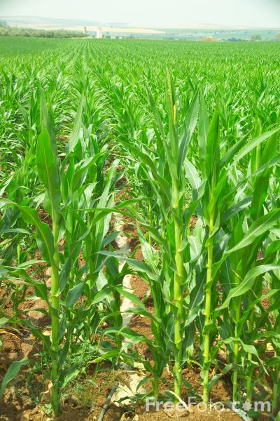

Turfgrass
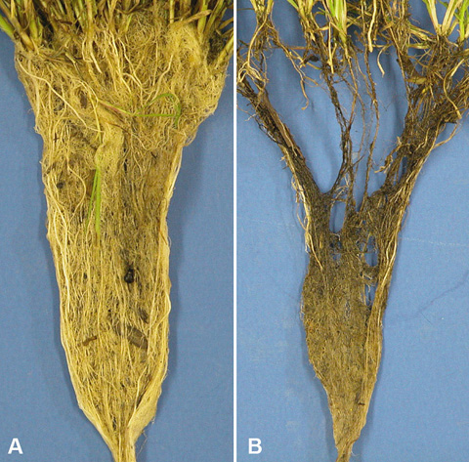

Dandelion
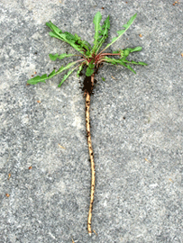

Maple Tree
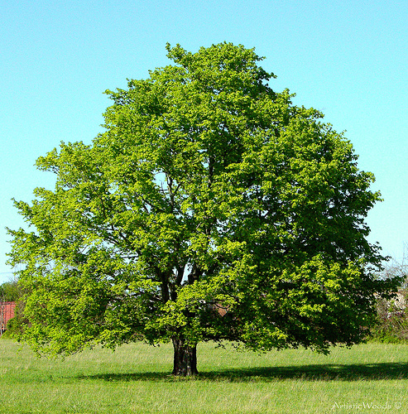

Potted Plant
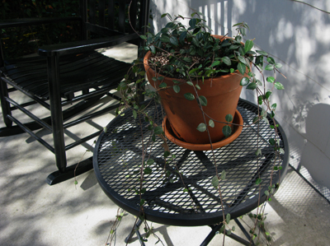

Aquatic “Plants” (Phytoplankton)
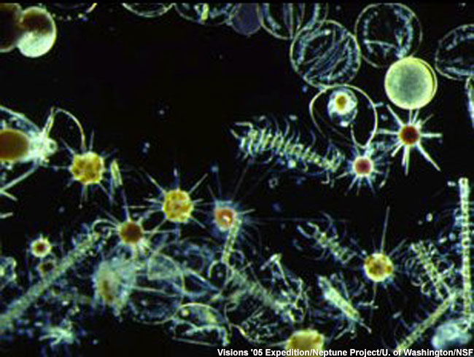

Activity 5: Organisms Give Off Carbon Dioxide

General Overview

TOTAL TIME:

Purpose

The purpose of this activity is for students to learn that all living organisms engage in cell respiration, which causes organic carbon to ultimately be found at CO₂ in the atmosphere.

Materials

Advance Preparation

Procedures

In the middle of the Pacific Ocean, there is a small island. Imagine only two types of animals live on the island: giraffes and lions. There are also trees and grass on the island. The island is an example of an ecosystem. Assume it is not disturbed by human beings. The ecosystem in the island is a sustainable ecosystem, which means that the population of each type of organism does not change over time.

You will use pictures and coins to build your model of the ecosystem. The pictures of organisms represent the matter of the organisms. You will have a box of pennies. The pennies represent the amount of energy each organism has. To simplify the problem, we use one penny to represent the amount of energy each organism stores in its body by growth, which is then available for organisms that consume it. Two pennies represent the amount of energy each organism uses for their bodily functions and movement, which consuming organisms cannot harness for their own use.

1. When you build the model, please stick pictures of the organisms onto the three levels. Put the coins besides each organism and make sure that each organism will have enough energy for both growth and bodily function and movement (3 coins). Remember that each trophic level does not receive all of the energy from the organisms below it that it consumed. Energy used for regular movement and activities is not available. How many trees do you have at level 1? How many giraffes do you have at level 2? How many lions do you have at level 3? Look at the table, what pattern do you find?

2. Please draw energy arrows to connect each level. What energy form is passed on from one level to the next level? Is there any energy released out of the biological system? If so, what form is that energy in?

Level 3. Lion

Level 2. Giraffe

Level 3. Trees

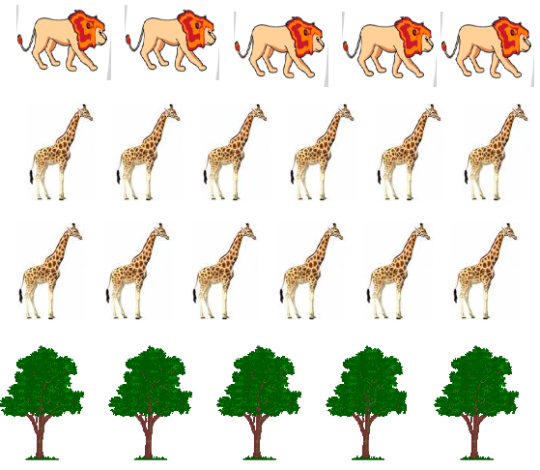
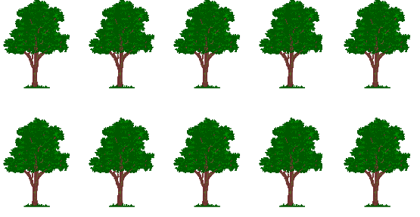

Answer:

If the student first chooses 9 trees, each tree will have 3 coins. Two of them become heat and only one of them goes to the second tropic level – giraffes. Altogether, there are 9 coins at the second tropic level. Since each giraffe needs 3 coins to survive, nine coins can support 3 giraffes. Each giraffe will consume 2 coins and pass on one coin to the third tropic level – lion. Altogether, there will be 3 coins passed on to the third tropic level, which can only support one lion.

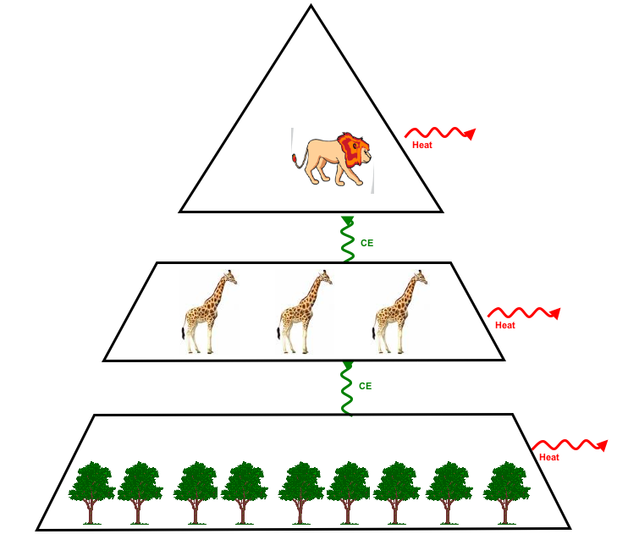

Activity 6: What Happens to dead plants and animals?

Overview
Introduction and review ~10 minutes

Questions about decomposers ~10 minutes
Process Tool and Discussion ~20 minutes

TOTAL TIME: 50 minutes

Materials
Student copies of Decomposition Questions
Process Tool

Advance Prep
Make copies of student handouts if not provided by MSU
Have process tool ready to use for Decomposition

Procedures

Introduction
Ask students the following question: What happens to dead plants and animals? Elicit students’ initial ideas about decomposition (What do they think happens to all the molecules that make up plants and animals, when the organisms die?)

Tell students they are going to learn more about how decomposition is related to changes in dead plant and animal materials, and how it changes the composition of air. Ask students what they know about decomposition: What are decomposers? (bacteria, fungus, detrivores, such as worms). What do decomposers “eat” and why do they think they eat that stuff?

Decomposer Lab

Process Tool and Summarizing Questions

Consider the following questions:
- Ask students how decomposition shows energy degradation (heat)?
- Ask students how decomposition shows energy conservation? (CE changes to KE, heat)
- Ask students how decomposition shows matter conservation?

When discussing Question 2, help students explain that ultimately the dead plant and animal material is used as food for the decomposers and that they give off waste products that are in the form of gases, so ultimately the dead plant and animal material ultimately become gases.

Review the following questions with students:
- Is decomposition a carbon source or sink? (source of CO2)
- How do decomposers influence the amount of organic carbon and carbon dioxide molecules that are in the carbon cycling (they turn organic carbon into carbon dioxide, so they increase the amount of carbon dioxide that is in the cycle)
- How does energy change during decomposition? (from chemical energy to kinetic and heat)

Name: _____________________________________Period/Hour:__________

Decomposition Questions
- What types of matter and forms of energy go into and out of mold cells during decomposition of bread? Complete the Diagram below.

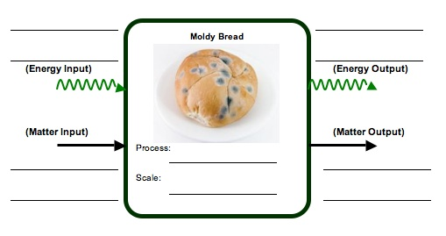

2. Think about how matter changes during decomposition. Would you agree or disagree that most dead plant and animal materials eventually become gases that go into the air? Support your ideas. ______________________________________________________
________________________________________________________________________________________________________________________________________________________________________________________________________________________________________________________________________________________

3. Decomposition is a process where decomposers use chemical energy found dead plants and animals. What happens to the chemical energy in this process? How does it change? ______________________________________________________________
__________________________________________________________________________________________________________________________________________________________________________________________________________________
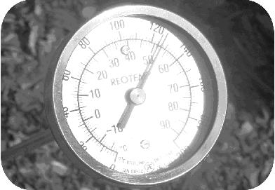
4. The picture shows a long stem thermometer inserted into a compost pile. The temperature reads 51°C (or 124°F). It is not uncommon for compost piles to reach this temperature and they can even reach higher temperatures that exceed 60°C.
Think about how energy changes during cellular respiration. Explain why the temperature of compost is so high? _________________________________________
__________________________________________________________________________________________________________________________________________________________________________________________________________________

5. Why do you think decomposition is important in the global carbon cycle? ______________________________________________________________________
__________________________________________________________________________________________________________________________________________________________________________________________________________________

6. How do decomposers change the amount of organic carbon molecules and carbon dioxide molecules that we have in the carbon cycle? ____________________________
__________________________________________________________________________________________________________________________________________________________________________________________________________________

Activity 7: Soil and the Carbon Cycle

General Overview:
Introduction: Review of the global carbon cycle, w/ focus on soil . ~ 10 minutes
Small Groups: What factors can increase or decrease soil carbon levels? ~ 15 minutes
Whole Class: Implications of soil carbon for global carbon balance. ~ 25 minutes

Estimated Time: 50 minutes

Purpose:
This lesson adds to the discussion the last major terrestrial component of the carbon cycle: soil organic carbon. Carbon that exists in living organisms often ends up in the soil for varying amounts of time after their death, depending on its composition. Carbon in sugars, proteins and other relatively-simple organic molecules tends to be rapidly respired by decomposing organisms as CO₂, but carbon in more complex molecules, particularly cellulose and lignin from plants, may remain for quite long periods in the soil before being fully decomposed. Students often carry the misconception that carbon from decaying organisms can then be directly taken up by the roots of living plants, forgetting that plants acquire their carbon in gaseous form during photosynthesis. Keep an eye and ear out for this way of reasoning during this activity.

Materials:
- Student handouts of Soil and Global Carbon Cycling
- Samples of plant litter and soils from several habitats (forest, grassland/pasture, farm field); or use pictures if season is wrong for gathering samples

Advance Preparation:
- Run copies of Soil and Global Carbon Cycling (if not provided by MSU)

Procedures:
Introductory discussion: Carbon Cycling ~10 minutes
- Begin the discussion by asking students to list some of the major forms of carbon in the bio- and atmosphere (CO₂, organic carbon w/ specific molecule examples). Although they are likely to be very familiar by this point with living organisms respiring CO₂ during regular metabolism, encourage students to consider what happens to all of the organic carbon that remains after organisms die. If necessary, prompt them to consider decomposers from the previous lesson, as a way to understand how most organic carbon is eventually respired. Depending on the molecule that carbon is tied up in, though, this respiration can take a long time to be completed if decomposers’ enzymes cannot easily break the molecule apart. In particular, cellulose and lignin, which are the major components of cell walls (and thus, wood) are very resistant to decomposition, and although they can be mechanically broken into smaller and smaller parts, biological breakdown (and release of CO₂) can take a very long time.

Small Group Discussion: Soils and Carbon Storage ~15 minutes
- Have the students break up into 6 groups (approx. 4 per group). Distribute the soil and litter samples and/or pictures, one to each group. Have them discuss how quickly carbon dioxide from their soil is likely to be released over the course of the growing season, how long it is likely to keep that carbon stored over its life, and what parts of the decaying plants will remain in the soil for the longest time. Make sure they take notes on their discussion and are prepared to share their answers with the rest of the class. If groups are struggling, suggest that they think about ways in which decomposition could be increased (i.e.- ways in which decomposers could respire faster). They benefit from the same things more familiar animals do: plentiful oxygen, moderate levels of water and moderate temperatures. The presence of these conditions will speed up decomposition rates in the soil.

Whole Class Discussion: Human Land Use Decisions ~25 minutes
- Bring the groups back together and have them share the results of their small group discussions using a blank transparency version of Soil and Global Carbon. After the groups have reported, move into a discussion of how human land use decisions can affect global carbon cycling by changing decomposition rates in soils. Probably the largest effect we have on soil carbon is by tilling soils for agriculture, where we not only break organic debris into smaller pieces by plowing (thus making it easier for decomposers to work on the species), but we also introduce large amounts of oxygen into the soil, greatly increasing the efficiency of the fungi and bacteria doing the bulk of the decomposition. Another effect is via the type of vegetation that we encourage (cf. Activity 5). Since woody species take much longer to decompose, the presence of forests as opposed to crop- and grasslands will keep more carbon out of the atmosphere for longer periods of time. In other words, the important take-home point for students is that soil carbon sequestration (retention) is primarily related to the types of plants growing on that soil, and the degree to which that soil is disturbed. Animal organic matter is not strongly related to soil carbon, simply because nearly all of our organic matter is quickly decomposed by decomposers.
Name: ________________________________________ Hour: __________

Soil and Global Carbon Cycling

Carbon can remain in organic compounds in the soil long after an organism dies, but different compounds are broken down by decomposers at very different rates. The “woodier” materials of certain plants, in particular, can take decades or even hundreds of years to fully decompose. In contrast, ecosystems with few woody species tend to lose soil carbon more rapidly to the environment. Working with your group and the soil sample provided, fill out the following table for your sample. Then listen as other groups report on their sample and fill out the rest of the table accordingly.

Soil and Litter Type | How long will at least some of the carbon remain in soil?  (Short-term, Moderate, Long-term) | In what form will most of the carbon be present in the soil?  (Lignin, Cellulose, Starch) | How much carbon could be released to the atmosphere by plowing of this soil?  (Little, Some, Lots)
Forest
Grassland
Annual Cropfield

1. Is it important to consider the abundance of animals present above a soil when it comes to estimating soil carbon? Why or why not?

2. What kind of human management decisions are most likely to affect soil carbon levels? What would you recommend land managers do to increase or hold steady the amount of carbon stored in soils in this area?

Activity 8: Putting It All Together

